MICROPROCESSING TODAY AND POSSIBLE FUTURE SOLUTIONS

For
Thomas Swartz
Technical Communications Instructor
Western Michigan University
Kalamazoo, Mi

By
Marcel Englmaier
IME 1020 Student

November 7, 2011
Table of Contents
Title Page --- --- --- --- --- --- --- --- --- --- --- --- --- --- --- --- --- --- --- --- 1

Table of Contents --- --- --- --- --- --- --- --- --- --- --- --- --- --- --- --- --- - 2

Abstract --- --- --- --- --- --- --- --- --- --- --- --- --- --- --- --- --- --- --- --- 3

Introduction --- --- --- --- --- --- --- --- --- --- --- --- --- --- --- --- --- --- --- --- 4
Background --- --- --- --- --- --- --- --- --- --- --- --- --- --- --- --- --- - 4
Purpose and Audience --- --- --- --- --- --- --- --- --- --- --- --- -- 4
The Problem --- --- --- --- --- --- --- --- --- --- --- --- --- --- --- --- --- - 5
Sources --- --- --- --- --- --- --- --- --- --- --- --- --- --- --- --- --- - 5
Working Definitions --- --- --- --- --- --- --- --- --- --- --- --- --- --- --- 6
Limitations --- --- --- --- --- --- --- --- --- --- --- --- --- --- --- --- --- - 6
Scope --- --- --- --- --- --- --- --- --- --- --- --- --- --- --- --- --- --- --- --- 6

Collected Data --- --- --- --- --- --- --- --- --- --- --- --- --- --- --- --- --- - 7
Hyperthreading --- --- --- --- --- --- --- --- --- --- --- --- --- --- --- 7
Cache Size --- --- --- --- --- --- --- --- --- --- --- --- --- --- --- --- --- - 9
Transistors --- --- --- --- --- --- --- --- --- --- --- --- --- --- --- --- --- - 10
Manufacturing Materials --- --- --- --- --- --- --- --- --- --- --- --- -- 12
Turbo Boost(Turbo Core) --- --- --- --- --- --- --- --- --- --- --- --- -- 12

Conclusion --- --- --- --- --- --- --- --- --- --- --- --- --- --- --- --- --- --- --- --- 13
Summary --- --- --- --- --- --- --- --- --- --- --- --- --- --- --- --- --- - 13
Interpretation of Findings and Recommendations --- --- --- --- --- - 14

Bibliography --- --- --- --- --- --- --- --- --- --- --- --- --- --- --- --- --- --- --- --- 15

Abstract
This paper aims to explain the problems with today’s microprocessor, while also stating possible solutions for solving these problems. As a processor becomes smaller and smaller, the individual electrons can begin to jump from circuit to circuit. Processor manufacturing companies have developed several techniques to avoid this issue until it must actually be addressed. Some possible ways of avoiding this issue are Hyperthreading, new types of transistors and materials, cache changes, and Turbo Boost technology. Through a combination of these technologies, the processor can become a more evolved form of itself.

Introduction
Background
The processor. It has been around for a very long time. Over its lifetime, the processor has shrunk in size. Once, the processor used to be the size of a large room. Now, it is no bigger than a square inch and no taller than a quarter inch. In the last few years, though, the processor has been a standardized size, but its contents have begun to become extremely small. Thus comes the term microprocessing. In 2002, Intel, a large computer hardware firm, developed a new method of processing called Hyperthreading(Popovich, 2002). This technique, defined in the ‘Working Definitions’ section, was originally developed for website processors(Popovich, 2002). Not more than two years later, Hyperthreading disappeared due to hardware drawbacks in the Intel Pentium processing family in which Hyperthreading was implemented. Then, in 2009, Intel announced that Hyperthreading is making a comeback(Sheinberg, 2009). Later, in 2010, AMD, Intel’s main competitor, announced they are also implementing Hyperthreading(Saetang, 2010). Hyperthreading is not the only new form of processing. Pre-1990s, processors used big transistors. Then, a new form of transistor called a MOSFET was developed and implemented, allowing for faster and more effective data processing. MOSFETs are much smaller than regular transistors, and therefore aided in the shrinking of the processor to the now-standard size. A few other techniques of processing were developed to aid in processing speed and processor size.
Purpose and Audience
The purpose of this research paper is to bring awareness to an ever-growing problem and to present possible solutions to that problem. The audience of this paper is anticipated to, at the very least, have some knowledge of computers, and some technical background. The audience can include gamers who are aware of their computing power, computer engineers who realize the problem exists and may be attempting to solve it, computer programmers who are forced to program around the problem, and anyone with any experience in the field of computing.
The Problem
As processors gain power, and become smaller, there will eventually be a point in time when processors cannot be shrunk anymore by today’s methods due to electrons. All methods of avoiding this problem: virtualization, Hyperthreading, programming around the problem, are exhausted. The processor developed at this point in time will contain electrons that jump from circuit to circuit. These, free electrons can and will cause massive destruction inside the processor, resulting in problems ranging from a program glitch to complete processor overheating and eventual meltdown. This is a very serious problem, and must be faced now, rather than later because even though this problem does not exist now, it will in potentially 5 years, or 10 years, and any problem solved now will result in better processors now, and faster advancement of the modern computer.
Sources
All sources are articles, whether Scholarly Journal articles or Popular Magazine articles, that were found using Western Michigan University’s online resources or the Interlibrary Loan Service. Most articles used are from the ACM Digital Library due to this database’s relevance to computing.

Working Definitions
- Hyperthreading: “Hyperthreading is a technology Intel developed that can boost PC performance up to 30 percent by enabling a single chip to work like two virtual chips. The feature is currently offered only in Intel Xeon processors targeted for use in workstations and servers.“ (Popovich, 2002).
- MOSFET - Metal Oxide Semiconductor Field-Effect Transistors (Bescond, 2009)
- Shrinking the processor – Refers to the distance between transistors being made smaller, not the actual processor dimensions.
- Parallel computing – use of multiple cores for one or more tasks.
- Virtualization – a form of Hyperthreading
- Free electrons- electrons jumping from circuit to circuit inside the processor.

Limitations
This paper will not explore the cost of production for any of the items mentioned herein. This paper will focus on desktop computing, the micro-processor. It will not focus on full-sized processors, nor will it focus on mobile-computing. Also, while mentioning multi-core processing, and parallel computing, this paper will not go in depth regarding these topics.
Scope
This report will cover multiple ways of solving the problem. The Collected Data section will cover Hyperthreading, Cache size, Transistors, Manufacturing Materials, and Turbo Boost technology. The Conclusion section will discuss how these topics contribute to the following possible solutions: one possible solution is to stop decreasing the processor size, and to increase the processors outside dimensions. The second solution is to add processing cores while decreasing the processor size. The third solution is to increase processing power while decreasing processor size. The fourth solution is increasing cache size. The last solution is to make a combination of all other solutions, and create a 3D processor.

Collected Data
Hyperthreading
While Hyperthreading was invented in 2002 and then abandoned, it is making a substantial comeback. Every higher-level processor(the more expensive type) sold now has Hyperthreading. Hyperthreading has made a comeback due to the ability to process multiple items almost simultaneously.
Hyperthreading is when one core of a processor is made to act like two cores. A core is normally made up of Processor Execution Resources, the Architecture State, and the Advanced Programmable Interrupt Controller. When a processor is Hyperthreaded, a core consists of two sets of Architecture States and Advanced Programmable Interrupt Controllers, but only one set of Processor Execution Resources, which is shared between the two sets. The following image shows this idea more clearly.

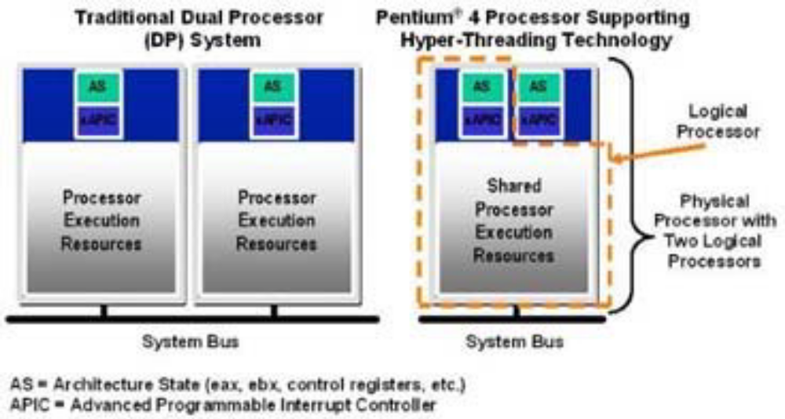
Figure 1: How Hyperthreading works.

Source: Madhura, Phatak + Dongaonkar Jr., 2009
The result of this is a processor which has a speed boost or about 30 percent over a non-Hyperthreaded processor(Popovich, 2002). Although Hyperthreading does give a noticeable boost, the amount of boost is highly dependent on the computer’s Operating System, and the applications being used(Madhura et al,. 2009). Parallel computing, as Hyperthreading is also called, provides faster results for almost anything. Very noticeably, the results of a scientific problem which the computer is solving will be returned much faster than those which a non-Hyperthreaded computer is solving(Ivanov, 2012).
Hyperthreading is a key factor in high performance virtualization(Simons+Buell, 2010). Virtualization is a form of using parallel computing to multi-task on one core. Normally, virtualization will function on one processor, with half the speed. But, since Hyperthreading, virtualization can effectively work at full speed on one core(Wang, Zang, Wang, Luo + Li, 2011). Unfortunately, under certain conditions, Hyperthreading does not always bring performance benefits(Wang et al., 2011).
Cache Size
A computer’s cache is very similar to a computer’s RAM. The RAM acts like temporary storage for the processor to use, but the computer’s cache acts as the processor’s feeding mechanism. If a command is waiting to be executed, the very simplest of code, Assembly Code, is stored in the computer’s cache. The more cache a computer has, the faster it can operate because it does not have to wait as long for more commands in the form of Assembly Code to be brought into the cache. There are three types of cache: Level 1 cache, Level 2 cache, Level 3 cache. Level 1 cache is assigned to each computer core individually, and is not allowed to communicate with other cores. It is its assigned core’s private stash of memory. Level 2 and Level 3 cache are both shared between processors. Level 2 is always shared, but Level 3 is only sometimes shared. The sharing of cache is a problem, as it creates performance lag. The Level 2 cache being shared by multi-core processors is one of the key performance bottlenecks of the processor(Rai, 2009) This problem is not exclusive to only Hyperthreaded processors. It occurs in every processor, and is a definite speed constraint(Rai, 2009). Level 2 cache has been designed as the key factor for scheduling tasks(Rai, 2009). This means that sometimes, processor cores need to wait, effectively diminishing performance, until the Level 2 cache sends them more commands. This problem is not exclusive to Level 2 cache. Level 3 cache, while not mostly shared, also creates problems. The Level 3 cache that is shared is also responsible for slowing down processing because of the fact that it is shared, and sometimes, processors must wait for commands(Crisp, 2009)

Transistors
Transistors are a fundamental part of every circuit. They are the basic on-off switches that allow a computer to function. Back when computers were the size of rooms, transistors didn’t exist. Instead, as on-off switches, vacuum tubes were used. Then, the transistor was invented, and computers shrunk exponentially. Computers became vastly smaller, and vastly faster. Lately, computer processors have been using MOSFETs, due to their sizes, and ease of fabrication.

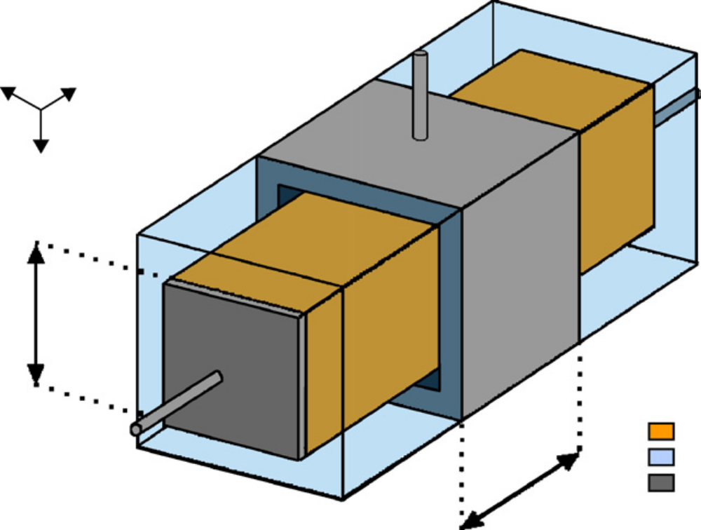
Figure 2: The Nanowire MOSFET

Source: Bescond, Lanoo, Michelini, Raymond, Pala, 2009)

The above image shows a nanowire MOSFET. These transistors are to replace the popular MOSFETs, which are so popular because of how simple they are. Power goes in one end, and comes out the other while sending a signal through the pin in the center. The above image is a 3D version, while the below image is what a transistor looks like in a processor.

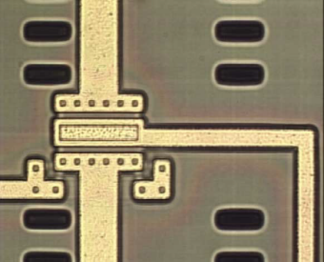
Figure 3: A Transistor in the Processor

Source: Wieland, Bonfert, Klumpp, Merkel, Nebrich, Weber, Ramm, 2005)

While transistors are generally of the same 2-dimensional design, processor development companies AMD and Intel both have different sized transistors. Intel uses 45 nanometer transistors in its i7 processor family, resulting in about 721 million transistors in the processor overall(Crisp, 2009). While the i7 family uses 45 nanometer transistors, the i3 and i5 processor families both use different, smaller, sizes. The reason the i7 processor family uses bigger transistors is because more power can be put through those transistors, resulting in faster processing. This is why the i7 processor family is the upper class of Intel’s processors.
A problem with these transistors, though, is that the traditional scaling of transistors is running out and slowing down. The microelectronics industry need an alternative to MOSFETs(Bescond, 2009). The traditional scaling is very simple. Just make the transistor smaller is beginning to become both expensive and slowly impossible. A possible solution to MOSFET transistors is the nanowire transistor, because it uses less space, and provides the same results(Bescond, 2009). But, these also suffer from higher sensitivity due to the nanometer scale(Bescond, 2009). These transistors, when enough power is put through them, can suffer from the ‘Free electron’ effect. This is very bad because these electrons can jump from circuit to circuit, and can possibly cause massive destruction.
Manufacturing Materials
While transistors becoming smaller can produce problems, so can the materials that processors are made from. Processors are made from very pure metals, silicon, and other materials designed specifically for use in microprocessors. As processors become smaller, the materials need to become more and more pure, else the impurities can produce problems.
The nanowire transistors mentioned above need a specific set of materials. The purity of the metal must be immense. The problem with this is that to make such a pure substance much money must be spent, and the process itself is very difficult to complete correctly with today’s manufacturing capabilities(Bescond, 2009). The presence of a foreign material, even in a MOSFET, provides for substantial electron transport differences(Bescond, 2009). The quantum conducatance is greatly impacted by impurities in the transistors, or any part of the processor(Bescond, 2009)
Turbo Boost(Turbo Core)
Turbo Boost technology has been around for a very long time. Turbo Boost is very similar to the ever-popular overclocking. Overclocking is the act of speeding up the processor by adjusting several processor settings including voltage, and processor multipliers. Overclocking, when not done correctly, provides for a very unstable processor, which is bound to over-heat and or crash.
While overclocking is potentially dangerous, Turbo Boost is not. AMD and Intel currently use a form of Turbo Boost technology to help speed up their processors(Saetang, 2010). Turbo Boost helps to limit the wastefulness of dormant computer cores by using the power that is wasted and overclocking the processing cores being used(Saetang, 2010). The Turbo Boost’s overclocking, though, is not damaging because it is being done in a controlled fashion, and has been designed into the processor before it was even manufactured. Turbo Boosting is very good because if a program, Mozilla Firefox for example, is the only program running, and is only using one core, then the processor can Turbo Boost that core, and temporarily slow down one or two of the other cores, effectively speeding up Mozilla Firefox without damaging the computer.
While Turbo Boost is a very good thing for computer speed, it also has a major drawback. When a processor decides to Turbo Boost, it also decides to produce extra heat. This heat can be dealt with if the computer has a good cooling unit, but if it does not, Turbo Boost can lead to overheating and an eventual computer crash.

Conclusion
Summary
Computer Engineers are exploring means of speeding up processing without facing major size restrictions or Free Electrons. Hyperthreading, Cache sizes, Turbo Boost technology, manufacturing materials, and transistors are all things that need to be worked with to design the next processor. The current processor, with the current advancements being made, will eventually have transistors so small and close together that more power cannot be run through them or else Free Electrons can cause massive processor damage. To avoid this, advancements need to be made. Hyperthreading must be made better, because there are sometimes serious lab issues associated with Hyperthreading. Cache sizes must be increased, and the use of cache memory must become more specialized. Doing this will eliminate the speed bottlenecks presented by Level 2 and Level 3 cache. When Turbo Boosting, the computer must be more intelligent about this to avoid overheating and power issues. The manufacturing process must be changed so that the materials used can be made more pure to avoid power and speed issues when processors become even smaller. Lastly, the transistors must be changed. New forms of transistors need to be developed to allow for the processor to become smaller. Nanowire transistors are a good start, but these depend on the manufacturing process to produce very pure metals and materials for use. If no one takes charge, the processor development will eventually hit a wall, and it could be many years before the wall can be overcome. It is better to build a bridge over the wall now rather than having to construct a ladder when the wall is nearer.
Interpretation of Findings
To create a new line of processors, all of the problems explained in this paper must be solved simultaneously. A processor must possess new algorithms and techniques for more effective Hyperthreading, an increased Cache size, a new method of Turbo Boosting the processor cores without problems, and new transistors. Also, as the processor size decreases, a new type of processor should be developed. Currently, processors are only 2-dimmensional, while they should become 3-dimmesnional. 3D processors would allow for more space to add more cores for parallel computing and virtualization. Adding more cores could also be of great benefit to multi-taskers. 3D processors can allow for size limitations to be overcome by creating multiple processing layers.

References
Bescond, M. M., Lanoo, F., Michelini, L., & Raymond, M. G. P. (2009). 3d real-space quantum transport simulation of nanowire mos transistors: influence of the ionized doping impurity. Microelectronics Journal, 40(4-5), 756-758. doi: 10.1016/j.mejo.2008.11.009
Crisp, S. (2009). What makes core i7 special. Personal Computer World, (01420232), n/a-n/a. Retrieved from http://search.proquest.com/docview/213521422?accountid=15099
Hyper-threading. Wikipedia. Wikipedia. Retrieved from http://en.wikipedia.org/wiki/Hyperthreading
Ivanov, L. (2012). The right balance: restructuring the parallel and scientific computing course. Journal of Computing Sciences in Colleges, 27(3), 115-121. Retrieved from ACM Digital Library
Madhura, A. Phatak. V., & Dongaonkar Jr., B. R. (2009). Applying hyperthreading technology for evaluating the performance of http server for stored audio/video retrieval. Emergin Trends in Engineering and Technology (ICETET), 2009 2nd International Conference, 644-647. doi: 10.1109/ICETET.2009.39
Popovich, K. (2002). Chip sets boost performance ; intel adds support for hyperthreading, faster bus and memory speeds. EWeek, 19(41), 28-28. Retrieved from http://search.proquest.com/docview/198521427?accountid=15099
Rai, J. K., Negi, A., Wankar, R., & Nayak, K. D. (2009). Characterizing l2 cache behavior of programs on multi-core processors: regression models and their transferability . Nature & Biologically Inspired Computing, 1673-1676. doi: 10.1109/NABIC.2009.539364
Saetang, D. (2010, Geektech. PC World, 28(6), 16-16. Retrieved from http://search.proquest.com/docview/347288178?accountid=15099
Sheinberg, B. (2009). Intel goes small to go big. CRN, , A.9-A.9. Retrieved from http://search.proquest.com/docview/227583499?accountid=15099
Simons, J., & Buell, J. (2010). Virtualizing high performance computing. ACM SIGOPS Operating Systems Review, 44(4), doi: 10.1145/1899928.1899946
Wang, X., Zang, J., Wang, Z., Luo, Y., & Li, X. (2011). Selective hardware/software memory virtualization. ACM SIGPLAN Notices - VEE '11, 46(7), doi: 10.1145/2007477.1952710
Wieland, R., Bonfert, D., Klumpp, A., Merkel, R., Nebrich, L., Weber, J., & Ramm, P. (2005). 3d integration of cmos transistors with icv-slid technology. Microelectronic Engineering, 82(3-4), 529-533. doi: 10.1016/j.mee.2005.07.052

